Neal Binstock - Board of Trustees
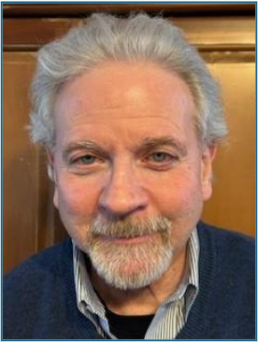
My wife, Karen Woodall, and I rejoined First Unitarian church in 2023. As I became more familiar with the church’s many activities and dimensions of service, as well as its congeniality, I was very glad that I had rejoined. In addition to attending services, I participate in the Men’s Group and I serve on the Safety Committee. I grew up in a Jewish family in Pittsburgh’s Highland Park area, with aunts and uncles and cousins nearby. Today I consider myself a “Jewish Unitarian,” a combination I find both comfortable and comforting. We live in Point Breeze, so I have expanded my East End roots into Shadyside and Squirrel Hill, where I am still surrounded by cousins and friends old and new.
Professionally, I have worked primarily in business services/operations and facilities management in academic settings. At Carnegie Mellon University I was Assistant Vice President for Business Services, Director of Facilities and Administration, and Assistant Dean (administrative) for the Graduate School of Industrial administration (now the Tepper School of Business). I retired from Robert Morris University as Senior Director of Legal Affairs reporting to the General Counsel (no, I am not an attorney). Prior to that I was Senior Director of Business Operations at Robert Morris. I have a B.A. in Psychology with minor(s) in Cost and Financial and Management accounting as well as Organizational Behavior and Business Law.
I serve on one other board: ARIA412, a small non-profit musical organization dedicated to making opera accessible and fun by performing in informal settings. I am Treasurer on that Board of Directors.
In a time when—like it or not—we must be mindful of civic, financial, and political circumstances that can affect our spiritual and collegial journey, I look forward to using my skills to assist the church. I am honored to serve, and I am humbled to help.

Clint Geller - Board of Trustees
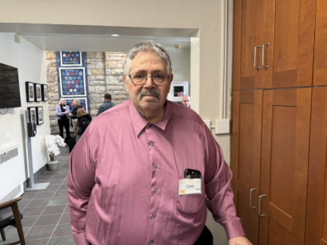
I am a semiretired 72 year old science consultant living in Squirrel Hill with my wife of nearly forty years, Maria, who is a retired educational psychologist. We have one child, our daughter Anne, age 34, who is a resident at the Johns Hopkins University Hospital in Baltimore. I grew up in Brooklyn, New York in a Jewish family, attending public schools, supported by my widowed mother after age nine.
I am a proud Cooper Union graduate with a physics PhD from the University of Illinois in 1979. After school, I took a job at the Westinghouse Bettis Atomic Power Laboratory in West Mifflin, from which I retired as a Senior Advisor Scientist in 2020. Since then, I have consulted part-time for a leading materials modeling software developer and contract research organization.
Having been a working scientist for half a century, science is at the center of my worldview. Though I also identify as a secular jew, I have enjoyed a lifetime of wonder and awe at the natural world without embracing supernatural explanations for it. I was very involved in progressive social action throughout my younger adulthood. Given the recent scary developments in our country, Maria and I jointly decided that we needed to connect with a larger community of people sharing our values, and to rejoin the struggle. So, in September of 2023, we began attending services at First UU, and impressed with what we saw and the people we met, we signed the book in the spring of the following year.
In First UU, both my main focus and Maria’s has been social justice work, and in particular, the eighth principle of our creed, to dismantle racism and oppression. We both joined the church’s Racial Justice Task Force very soon after coming to First UU and we have become liaisons to the Bethel AME congregation in the Hill. We support their efforts to recover their long and distinguished history, and to address their community’s urgent needs for affordable housing and food security. Reverend Snyder, the pastor of Bethel AME, counts on our continued support, and we have made friends in that community. Maria and I also represent the RJTF on the recently reactivated Forum Committee, in which capacity we help to bring in speakers on important social justice, science, and historical topics. I also belong to the First UU’s Humanist Group.

Susan Whittaker – Board of Trustees
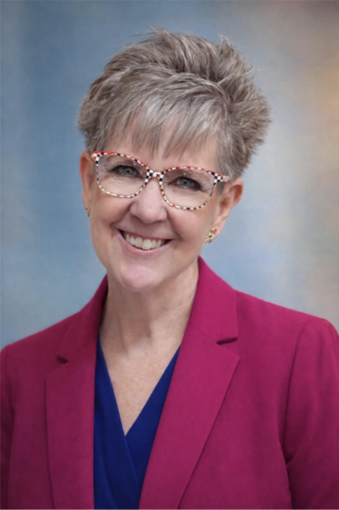
I have been a member of First Unitarian Church of Pittsburgh since May 2020, joining alongside my husband, Mark, just one week before the world changed with the COVID-19 shutdown. A lifelong resident of Pittsburgh’s eastern area, I am fortunate to have my triplet daughters and six grandchildren all living within seven miles of me. My professional path led me to nursing as a second career in my 30s, and I hold a BSN from Pennsylvania Western University (formerly California University of PA). My experience spans the ICU, hospice care, and nursing management—roles that require both composure and a compassionate heart. Outside of work, I am a dedicated cat rescue volunteer and foster, sharing our home with seven cats and a Bernese Mountain Dog.
Mark and I began our search for a meaningful church home shortly after marrying in 2011. We were drawn to First Unitarian’s deep commitment to social justice, its spirit of radical acceptance, and its vibrant community life. We knew we had found our place within our first year of attendance. Now, I am eager to give back to the congregation that has welcomed us so warmly. I look forward to the opportunity to serve on the Board of Trustees, bringing a purposeful and dedicated perspective to our church's future.

Tony Rutigliano - Nominating Committee
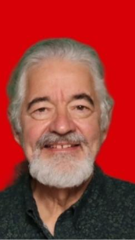
My wife Karen and I joined the First Unitarian Church in 2018, having been UUs since 2000. I spent much of my career in consulting and practitioner positions in which I helped organizations become more effective at leadership/management development and employment practices. It was my job at Highmark that brought us to Pittsburgh in 2017, from the New York City suburbs.
Besides our two children and 3-1/2-year-old granddaughter, Karen and I love reading, travelling, the arts and entertaining. I am Vice President of the Frick Park Lawn Bowling Club.
At church I have served on the Social Committee since Thanksgiving 2024. I love cooking and regularly volunteer to do so for 1Hood and other organizations.

Danielle Staresinic – Nominating Committee
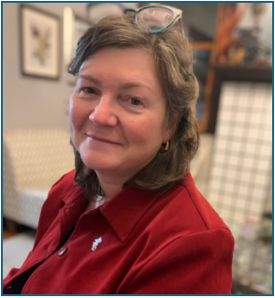
Danielle Staresinic has been part of First Unitarian Church for 27 years, where her four children grew up in this welcoming community. She has served as a Religious Education instructor for 4th–5th graders and as a volunteer substitute teacher. An optometrist in Lawrenceville for 30 years, Danielle also volunteers with Rotary and as a Girl Scout leader. After a little gentle arm-twisting from Hugh, she’s glad to help connect members’ gifts with meaningful opportunities to serve.

Karen Woodall – Nominating Committee
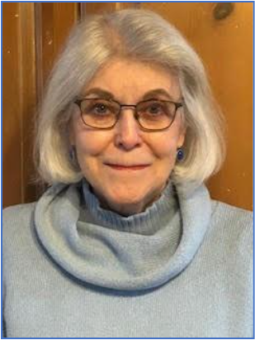
I initially discovered First UU while a graduate student at Pitt and regularly attended while Paul Beattie was pastor. After finishing my clinical psychology degree, I was living part time in St. Clairsville, Ohio and part-time in Pittsburgh where I continued to work in research and to build my private clinical practice. During this time, I was a member of the Ohio Valley UU Congregation.
Now living full-time in Pittsburgh, my husband, Neal Binstock, and I joined First UU in 2003. We were grateful and relieved (!) when Neal’s Jewish parents gave us their blessing to be members, and we enjoyed participating in one of the original Covenant Groups. However, the demands of elder care, careers, and a job change requiring recurring travel contributed to our dropping from membership a few years later.
Now both retired, Neal and I were happy to renew our membership in 2023. I am currently on the Pastoral Care Team and co-lead a Grief Support Group with Christine Beregi. I also enjoy being a member of Women’s Alliance. We both have been uplifted by the warmth and welcome of the First UU community and by the opportunities the church affords to meaningfully support UU principles. We look forward to becoming more involved.

